Student Name: Yuyang Gong Student Number: 49079984 Team Name: FriendZone
Week: 4
Title: Turning Interview Data into Design Principles

Description:
We grouped the interview material into themes including difficulty entering an existing group, gradual motivation to connect, a spectrum of comfort, the role of particular spaces and common interests as a bridge. These themes led to practical principles: support smaller groups, provide a shared purpose, allow different levels of participation and help users continue a connection after the first meeting.
This synthesis moved the project away from a generic event-discovery service. The emerging opportunity was to support the fragile transition between noticing an activity and feeling able to join it. We began to frame FriendZone as a bridge from online preparation to face-to-face participation.
Visual Evidence:
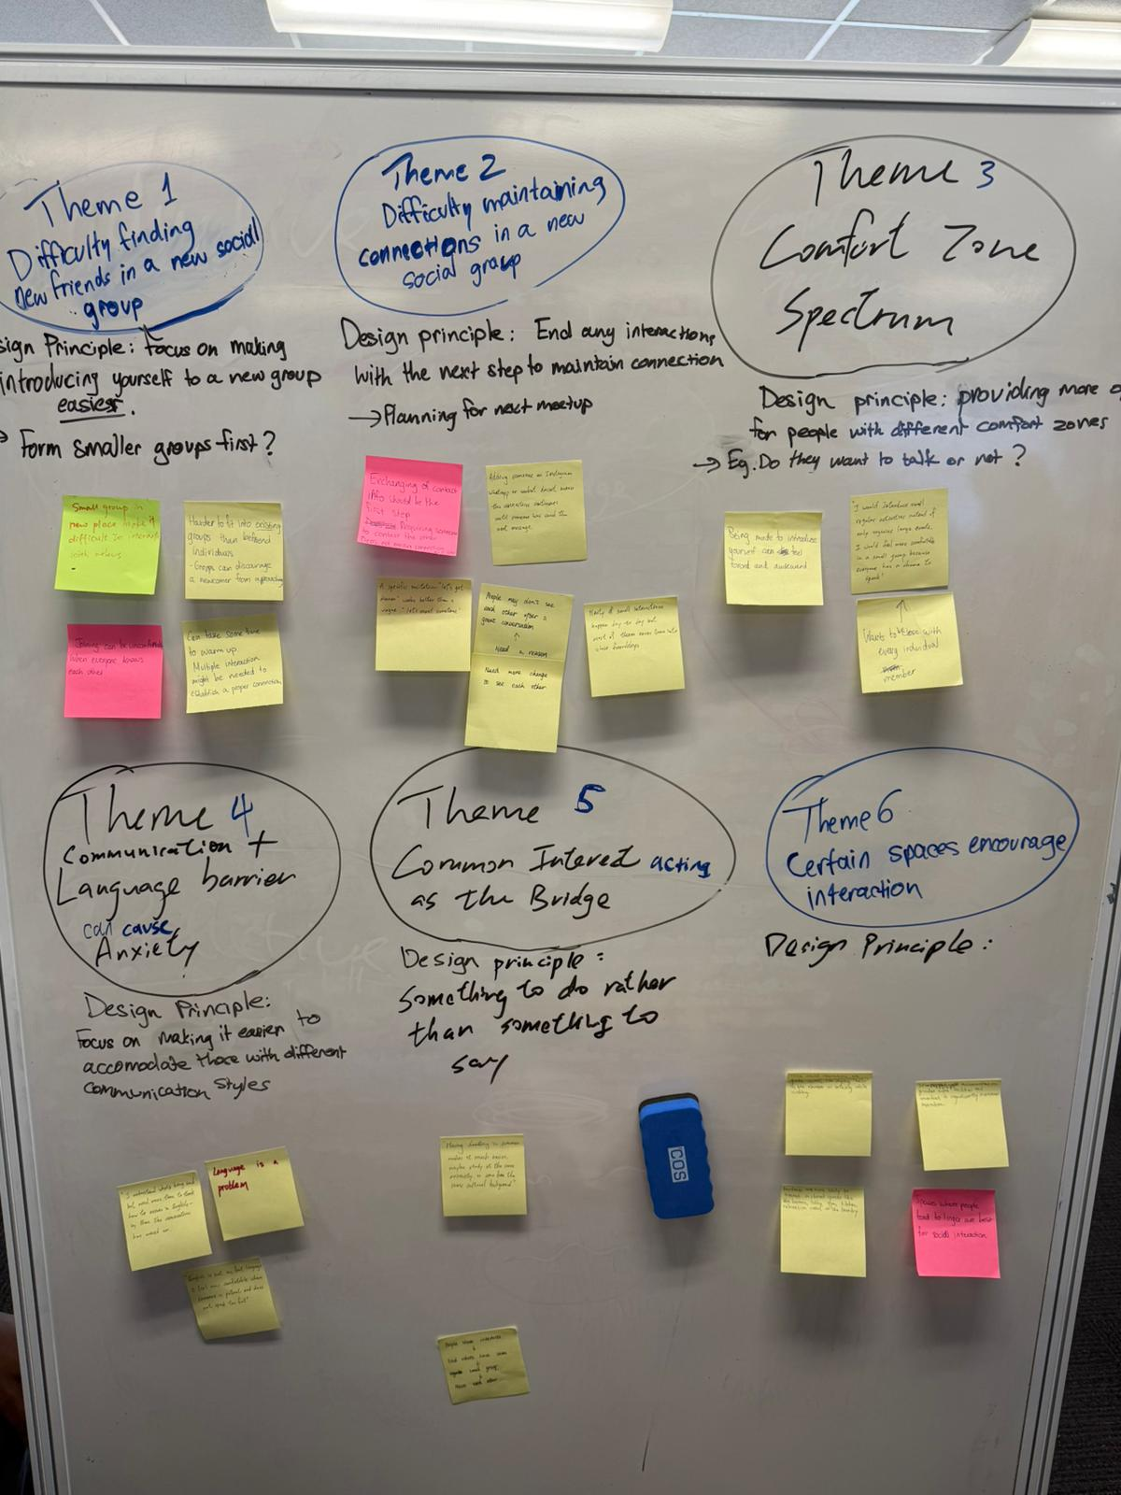
Affinity mapping used to group interview findings into themes and design principles.
Statement on Learning:
I learned that synthesis is not just summarising comments. The value comes from connecting evidence to a design implication and being able to explain that connection. The affinity map made gaps visible and helped the team agree on principles that could later be tested through a prototype.

